E-Commerce Retail Dataset- SQL REPORT
Analyst: Akhimien Evelyn
541,909 - Raw Records
524,878 - Clean Records
8 - Columns
38 - Countries
Date Range - Dec 2010 – Dec 2011
Transnational e-commerce transactions from a UK-based online retailer
This dataset contains all transactions occurring between December 2010 and December 2011 for a UK-based non-store online retailer. The company sells unique all-occasion gifts, and many of its customers are wholesalers. Each row represents one line item within an invoice.

- SELECT EVERYTHING
SELECT * FROM [ONLINE RETAIL CLEANED]
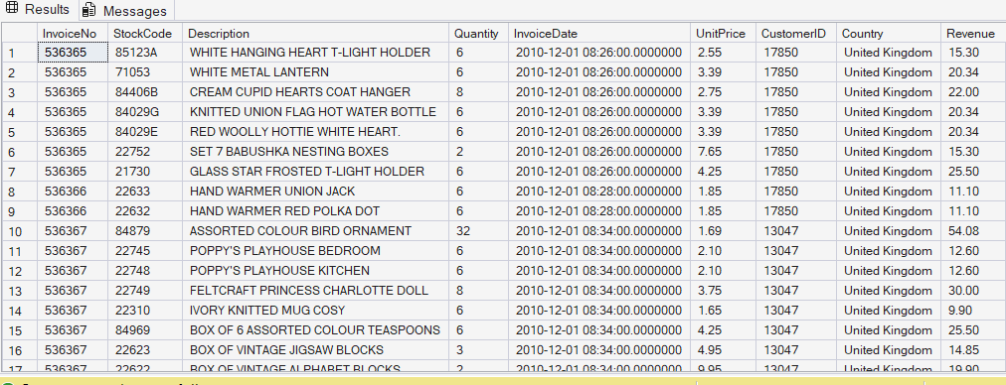
- TOTAL ROW
SELECT COUNT(*) AS Total_Rows FROM [ONLINE RETAIL CLEANED]
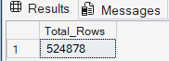
- BASIC STATISTICS
SELECT
MIN(Quantity) AS Min_Qty,
MAX(Quantity) AS max_qty,
AVG(Quantity) AS avg_qty,
STDEV(Quantity) AS StdDev_Quantity,
MIN(UnitPrice) AS min_price,
MAX(UnitPrice) AS max_price,
AVG(UnitPrice) AS avg_price,
MAX(Revenue) AS max_Revenue,
AVG(Revenue) AS avg_Revenue,
MIN(Revenue) AS Min_Revenue,
STDEV(UnitPrice) AS StDev_price
FROM [ONLINE RETAIL CLEANED]
- TOTAL REVENUE AND TOTAL ORDERS
SELECT
ROUND(SUM(Revenue), 2) AS Total_Revenue,
COUNT(DISTINCT InvoiceNo) AS Total_Orders
FROM [ONLINE RETAIL CLEANED]
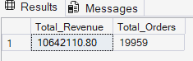
- Load or Confirm the Table Exist
SELECT TABLE_NAME FROM INFORMATION_SCHEMA.TABLES
WHERE TABLE_NAME = 'ONLINE RETAIL CLEANED'
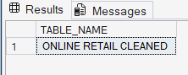
- LOAD/VIEW FIRST 10 ROWS
SELECT TOP 10 * FROM [ONLINE RETAIL CLEANED]
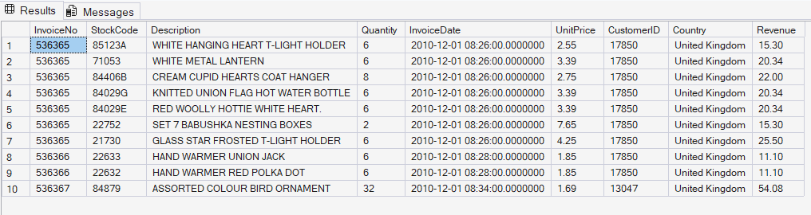
- NUMBER OF COLUMNS
SELECT COUNT(*) AS Total_Columns
FROM INFORMATION_SCHEMA.COLUMNS
WHERE TABLE_NAME = 'ONLINE RETAIL CLEANED'
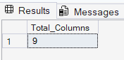
- DISTINCT VALUES IN EVERY CATEGORICAL COLUMN
SELECT
COUNT(DISTINCT InvoiceNo) AS Unique_Invoices,
COUNT(DISTINCT StockCode) AS Unique_Products,
COUNT(DISTINCT Description) AS Unique_Descriptions,
COUNT(DISTINCT CustomerID) AS Unique_Customers,
COUNT(DISTINCT Country) AS Unique_Countries
FROM [ONLINE RETAIL CLEANED]
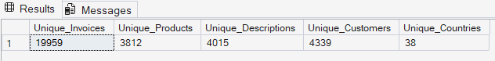

- TOP 10 COUNTRIES
SELECT TOP 10 COUNTRY,
COUNT(*) AS Transaction_Count
FROM [ONLINE RETAIL CLEANED]
GROUP BY Country
ORDER BY Transaction_Count DESC
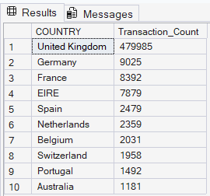

EXPLORATORY ANALYSIS
- TOP SELLING PRODUCTS (BY REVENUE)
SELECT TOP 10 Description,
COUNT(*) AS Transaction_Count,
SUM(Quantity) AS Quantity,
ROUND(SUM(Revenue), 2) AS Revenue,
ROUND(AVG(UnitPrice), 2) AS Avg_Price
FROM [ONLINE RETAIL CLEANED]
WHERE Description IS NOT NULL
GROUP BY Description
ORDER BY Revenue DESC
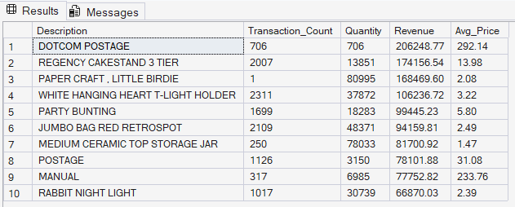

- HIGHEST REVENUE GENERATING COUNTRIES
SELECT TOP 10 Country,
COUNT(DISTINCT InvoiceNo) AS Total_Orders,
COUNT(DISTINCT CustomerID) AS Total_Customers,
SUM(Quantity) AS Total_Units_Sold,
ROUND(SUM(Revenue), 2) AS Total_Revenue,
ROUND(SUM(Revenue) * 100.0 /
SUM(SUM(Revenue)) OVER (),2) AS Revenue_Pct
FROM [ONLINE RETAIL CLEANED]
GROUP BY Country
ORDER BY Total_Revenue DESC
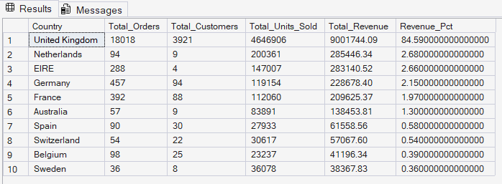

- MONTHLY SALES TREND
SELECT YEAR(InvoiceDate) AS YEAR,
MONTH(InvoiceDate) AS Month_Num,
DATENAME(MONTH,InvoiceDate) AS Month_Name,
COUNT(DISTINCT InvoiceNo) AS Total_Orders,
SUM(Quantity) AS Total_Units_Sold,
ROUND(SUM(Revenue), 2) AS Monthly_Revenue,
ROUND(AVG(Revenue), 2) AS Avg_Order_Revenue
FROM [ONLINE RETAIL CLEANED]
GROUP BY
YEAR(InvoiceDate),
MONTH(InvoiceDate),
DATENAME(MONTH, InvoiceDate)
ORDER BY YEAR, Month_Num
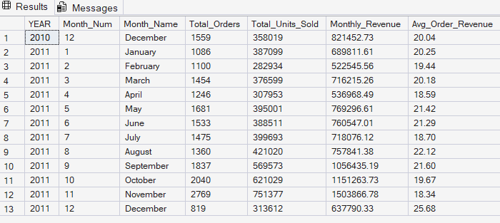

- MOST PURCHASED PRODUCTS (BY QUANTITY)
SELECT TOP 10 Description AS Product,
SUM(Quantity) AS Total_Units_Sold,
COUNT(DISTINCT InvoiceNo) AS Orders_Containing_Product,
COUNT(DISTINCT CustomerID) AS Customers_Who_Bought,
ROUND(AVG(UnitPrice), 2) AS Avg_Price
FROM [ONLINE RETAIL CLEANED]
WHERE Description IS NOT NULL
GROUP BY Description
ORDER BY Total_Units_Sold DESC
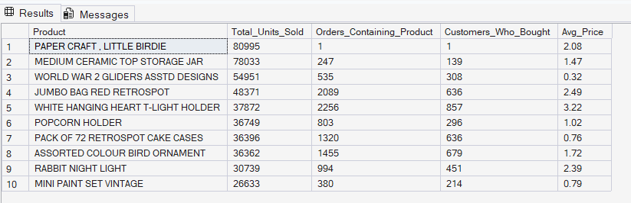

- CUSTOMER PURCHASING BEHAVIOUR
SELECT TOP 15 CustomerID, Country,
COUNT(DISTINCT InvoiceNo) AS Total_Orders,
SUM(Quantity) AS Total_Items_Bought,
ROUND(SUM(Revenue), 2) AS Total_Spent,
ROUND(AVG(Revenue), 2) AS Avg_Order_Value,
MIN(CAST(InvoiceDate AS date)) AS First_Purchase,
MAX(CAST(InvoiceDate AS date)) AS Last_Purchase,
DATEDIFF(DAY,
MIN(InvoiceDate),
MAX(InvoiceDate)) AS Date_Diff
FROM [ONLINE RETAIL CLEANED]
WHERE CustomerID IS NOT NULL
GROUP BY CustomerID, Country
ORDER BY Total_Spent DESC
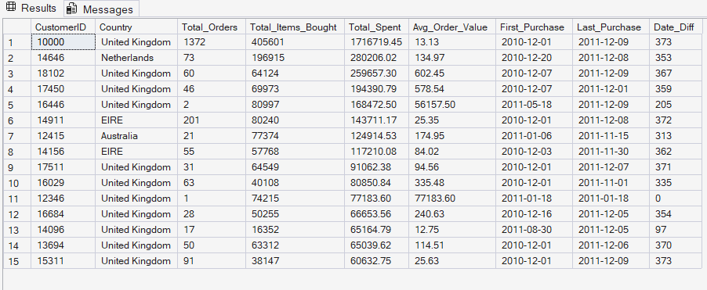
- --- ORDER SIZE DISTRIBUTION
SELECT CASE
WHEN Quantity BETWEEN 1 AND 5 THEN '1-5 Units'
WHEN Quantity BETWEEN 6 AND 10 THEN '6-10 Units'
WHEN Quantity BETWEEN 11 AND 20 THEN '11-20 Units'
WHEN Quantity BETWEEN 21 AND 50 THEN '21-50 Units'
WHEN Quantity BETWEEN 51 AND 100 THEN '51-100 Units'
ELSE '100+ UNITS'
END AS Order_Size_Group,
COUNT(*) AS Num_Transactions,
ROUND(COUNT(*) * 100.0/
SUM(COUNT(*)) OVER(), 2) AS Pct_Of_Total
FROM [ONLINE RETAIL CLEANED]
GROUP BY
CASE
WHEN Quantity BETWEEN 1 AND 5 THEN '1-5 Units'
WHEN Quantity BETWEEN 6 AND 10 THEN '6-10 Units'
WHEN Quantity BETWEEN 11 AND 20 THEN '11-20 Units'
WHEN Quantity BETWEEN 21 AND 50 THEN '21-50 Units'
WHEN Quantity BETWEEN 51 AND 100 THEN '51-100 Units'
ELSE '100+ UNITS'
END
ORDER BY MIN(Quantity)
